**Steeve Data Analysis Challenges**

**Challenge 1 - Steve's Car Showroom**

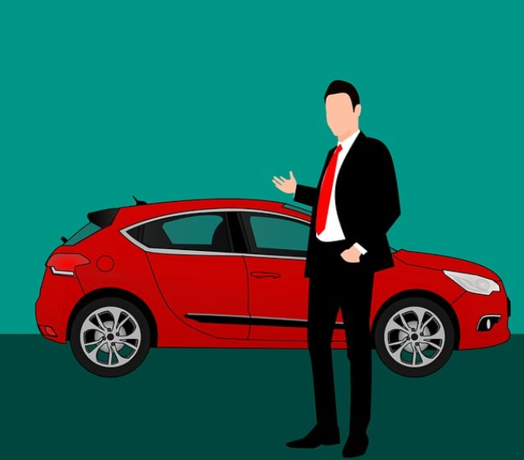

**Intro**

Steve runs a top-end car showroom but his data analyst has just quit and left him without his crucial insights.  
Can you analyse the following data to provide him with all the answers he requires

**Tables**

Here are the tables you will be using

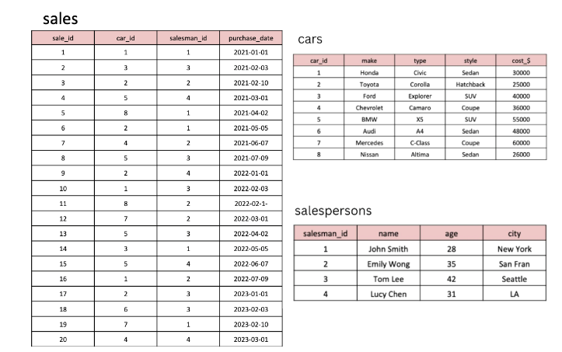

**1. What are the details of all cars purchased in the year 2022?**

**SELECT * FROM cars**

**INNER JOIN sales**

**ON cars.car_id = sales.car_id**

**WHERE YEAR(purchase_date) = 2022;**

**2. What is the total number of cars sold by each salesperson?**

**SELECT sp.salesman_id, name,**

**count(sale_id) AS cars_sold**

**FROM salespersons sp**

**INNER JOIN sales s**

**ON sp.salesman_id = s.salesman_id**

**GROUP BY salesman_id**

**ORDER BY count(sale_id) DESC;**

**3. What is the total revenue generated by each salesperson?**

**SELECT**

**sp.salesman_id,**

**sp.name,**

**count(s.sale_id) AS cars_sold,**

**SUM(c.cost_$) as total_revenue**

**FROM**

**salespersons sp**

**INNER JOIN sales s**

**ON sp.salesman_id = s.salesman_id**

**INNER JOIN cars c**

**ON s.car_id = c.car_id**

**GROUP BY salesman_id**

**ORDER BY SUM(cost_$) DESC;**

**4. What are the details of the cars sold by each salesperson?**

**SELECT c.make, c.type, c.style, sp.name**

**FROM cars c**

**INNER JOIN sales s**

**ON c.car_id = s.car_id**

**INNER JOIN salespersons sp**

**ON s.salesman_id = sp.salesman_id;**

**5. What is the total revenue generated by each car type?**

**SELECT type,**

**SUM(cost_$) as total_revenue**

**FROM cars**

**GROUP BY type**

**ORDER BY total_revenue DESC;**

**6. What are the details of the cars sold in the year 2021 by salesperson 'Emily Wong'?**

**SELECT c.make, c.type, c.style, sp.name**

**FROM cars c**

**INNER JOIN sales s**

**ON c.car_id = s.car_id**

**INNER JOIN salespersons sp**

**ON s.salesman_id = sp.salesman_id**

**WHERE YEAR(s.purchase_date) = 2021 AND sp.name = "Emily Wong";**

**7. What is the total revenue generated by the sales of hatchback cars?**

**SELECT style,**

**SUM(cost_$) as total_revenue**

**FROM cars**

**WHERE style = "Hatchback";**

**8. What is the total revenue generated by the sales of SUV cars in the year 2022?**

**SELECT style,**

**SUM(cost_$) as total_revenue**

**FROM cars**

**INNER JOIN sales**

**ON**

**cars.car_id = sales.car_id**

**WHERE style = "SUV" AND YEAR(purchase_date) = 2022;**

**9. What is the name and city of the salesperson who sold the most number of cars in the year 2023?**

**SELECT sp.name, sp.city,**

**count(sale_id) AS cars_sold**

**FROM salespersons sp**

**INNER JOIN sales s**

**ON sp.salesman_id = s.salesman_id**

**GROUP BY sp.name, sp.city**

**ORDER BY**

**count(sale_id) DESC LIMIT 1;**

**10. What is the name and age of the salesperson who generated the highest revenue in the year 2022?**

**SELECT sp.name, sp.age,**

**count(s.sale_id) AS cars_sold,**

**SUM(c.cost_$) as total_revenue**

**FROM salespersons sp**

**INNER JOIN sales s**

**ON sp.salesman_id = s.salesman_id**

**INNER JOIN cars c**

**ON s.car_id = c.car_id**

**WHERE YEAR(purchase_date) = 2022**

**GROUP BY sp.name, sp.age**

**ORDER BY**

**SUM(cost_$) DESC LIMIT 1;**